**A REPORT ON SOCIAL NETWORK ADS DATA SET**

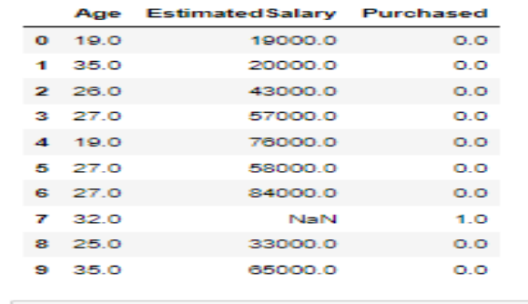The Social Network Ads dataset shows insight into the relationship between social Networks and purchase using the range of people’s age and their estimated salary. This dataset consists of 400 data points (rows) and features 3 informative columns: ‘Age’, ’Estimated Salary’ and ‘purchase’. It shows a brief view of the impact of different factors on the purchase. Below are the first 10 rows of the dataset. The 10 rows are picked from 0-9).

Distribution of the social networks, broken down by age and estimated salary, is shown in the chart below.

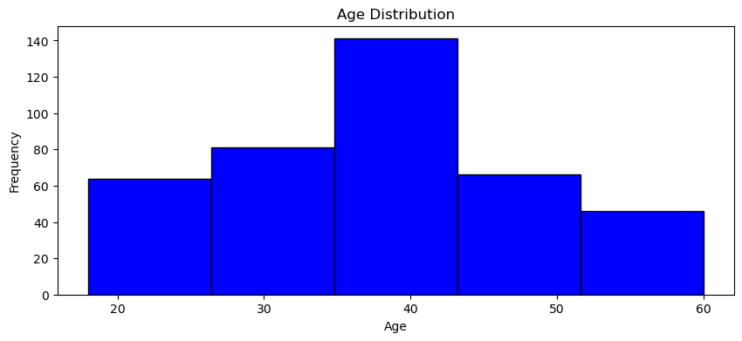

**Age Distribution:** The distribution of age shows a normal or centre skew pattern which indicates that the rate of purchase increased among persons between 30 to 46 years old. Overall, the data indicates a central tendency around 37.68 with a moderate degree of variability, making it somewhat normally distributed with a slight positive skew.

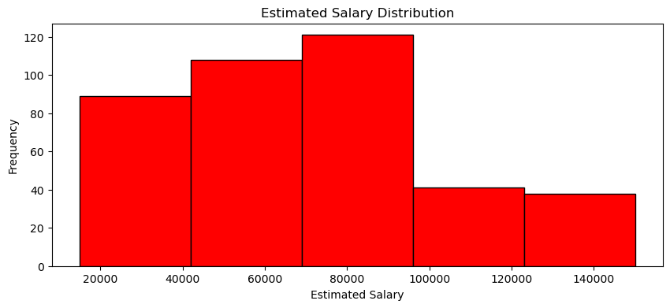

**Estimated Salary Distribution:** The Chart above shows that the distribution of estimated salary displays a right skew pattern which indicates that purchase level increased with estimated salary from 74,000 to 93,000. In the above chart the rate of estimated salary tends to decrease indicating that the progression goes from lower to higher level of salary. These statistics collectively suggest that the is an increase in spending within this range.

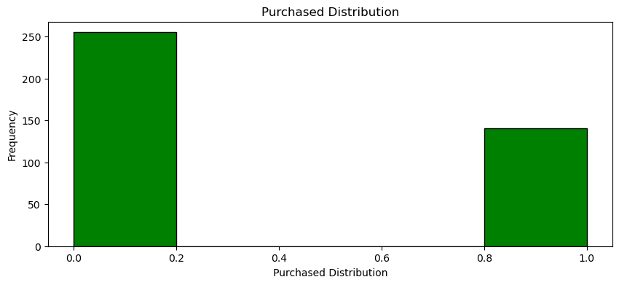

**For purchase:**  Those that did not purchase is of higher population than those who purchased. The chart above provides a visualization of the distribution of Purchased. Notably, this information sheds light on the number of purchased and the number of the not purchased ads. These statistics collectively suggest that the distribution of purchased is known as 0s and 1s. The exact number of the people that did not purchase is 255 and those that purchase is 141 persons from the value count.

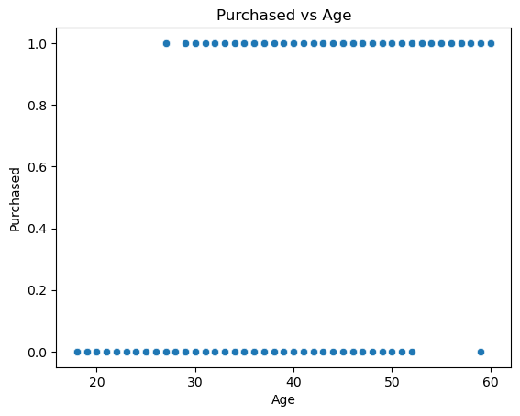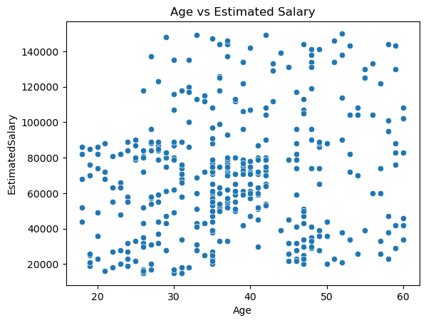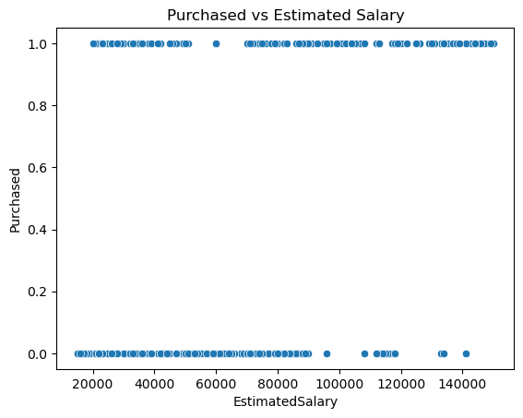

The scatter plots displayed above depicts the relationship between age and estimated salary, age and purchased, and estimated salary and purchased and their respective impacts on each other.

**PURCHASE VS ESTIMATD SALARY:** This shows for those that purchased they earned from 22000 to 50000 and 70000 to 140000. For those that didn’t purchase, their salary ranges from 15000 to 90000. People who earn lower tend not to purchase the ads.

The higher salary earners are of much population this shows that people that tend to purchase the ads earn higher salary while those that didn’t purchase are considered as low salary earners meanwhile most of the high earner choose not to purchase the ads as well.

**PURCHASED VS AGE:** In chart illustrate that the lower concentration of those that didn’t purchase falls within the age of 17-28 years. Persons of age 17-28 didn’t consider purchasing the Ads while people between the age range of 53 to 60 purchased the Ads. This also shows that people in in their prime or old age tend to buy more than the younger aged persons.

**AGE VS ESTIMATED SALARY:** In this plot, it is evident that people from age 17- 28 didn’t earn much salary while age 29- 60 earn more salary. Also, looking at the chart, there is a cluster which means that people of lower age range 20 to 28 years tend to be of higher population and they earned between 17,000 to 83,000 compared to other age range.

The people of low age range earned between 17,000 to 84000. Meanwhile people of age 28 to 60 tend to receive higher salary from 84000 to 140000 above which tend to affect their buying decision.

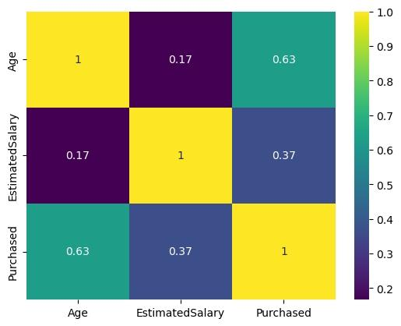

The Above Heat Map chat shows correlations between different variables (Age, Estimated Salary and Purchased). Age and Purchased have a strong positive correlation of approximately 0.630, indicating that as the Age distribution increases, purchased tend to increase significantly.

Estimated Salary and Purchased have a moderate positive correlation of around 0.370, suggesting that there is a moderate positive relationship between Estimated Salary and Purchased.

An increase in Estimated Salary is associated with a moderate increase in Purchased.

Age and Estimated Salary distribution exhibit a less consistent or very weak correlation around 0.170, indicating a minimal relationship between Estimated Salary and Age.

**CONCLUSION**

In conclusion, this dataset provides valuable insights into the impact of Social network on sales across distributions. Age distribution shows the strongest correlation with Purchased, followed by estimated Salary, while age distribution and estimated Salary has the weakest correlation.

The three explanatory Analyses in the report are univariate, bivariate, and multivariate.

Executives and management can use these research and results to inform about Social Network plans and decision-making for the company in an effort to boost productivity and sales.